Bunting Stations - 4 Corners
Purpose:
Allows the entire team the opportunity to practice and focus on bunting.
Equipment:
Each base is used as a home plate. Each player will need a glove. Bat, helmet and a couple balls at each station. Cones or baseballs can be used for competitions.
Setup:
This can be a 3 or 4 station drill, a coach or player throwing the pitch, a player bunting, and 2 players fielding.
Cones or baseballs can be used to create bunting areas down the lines.
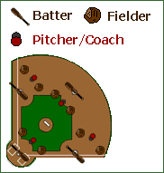
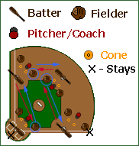
Execution:
Players will take turns rotating within their station. Each player will get a chance to bunt 10 balls. Players should be working on correct bunting fundamentals and trying to bunt the ball down the lines. The field is set up in a way that the foul lines and base lines can be used to determine whether a ball is fair or foul.
After each player has had a chance to go around once or twice, change to a station competition. Each player gets 10 pitches, the player with the most bunts fair and in the bunting area wins.
Finally you can use this as a timed workup game similar to pepper. The goal is to be the person bunting at home plate when the game is over. Start all the stations bunting, the batter stays up as long as he bunts the ball in the safe zone. Once he misses, he will move to the first base position and the third base position will rotate to bat. All rotation will happen within each station until you yell "Rotate"! When you yell rotate the batter from each station (except for home plate) will move up to the next station replacing the first baseman, who will become the bunter at the prior station.

